**MEEM 5250 Internal combustion Engines**

**11/04/2013**

**SI Combustion Analysis (Part II)**

**Assignment 05**

**Arjun Darbha**

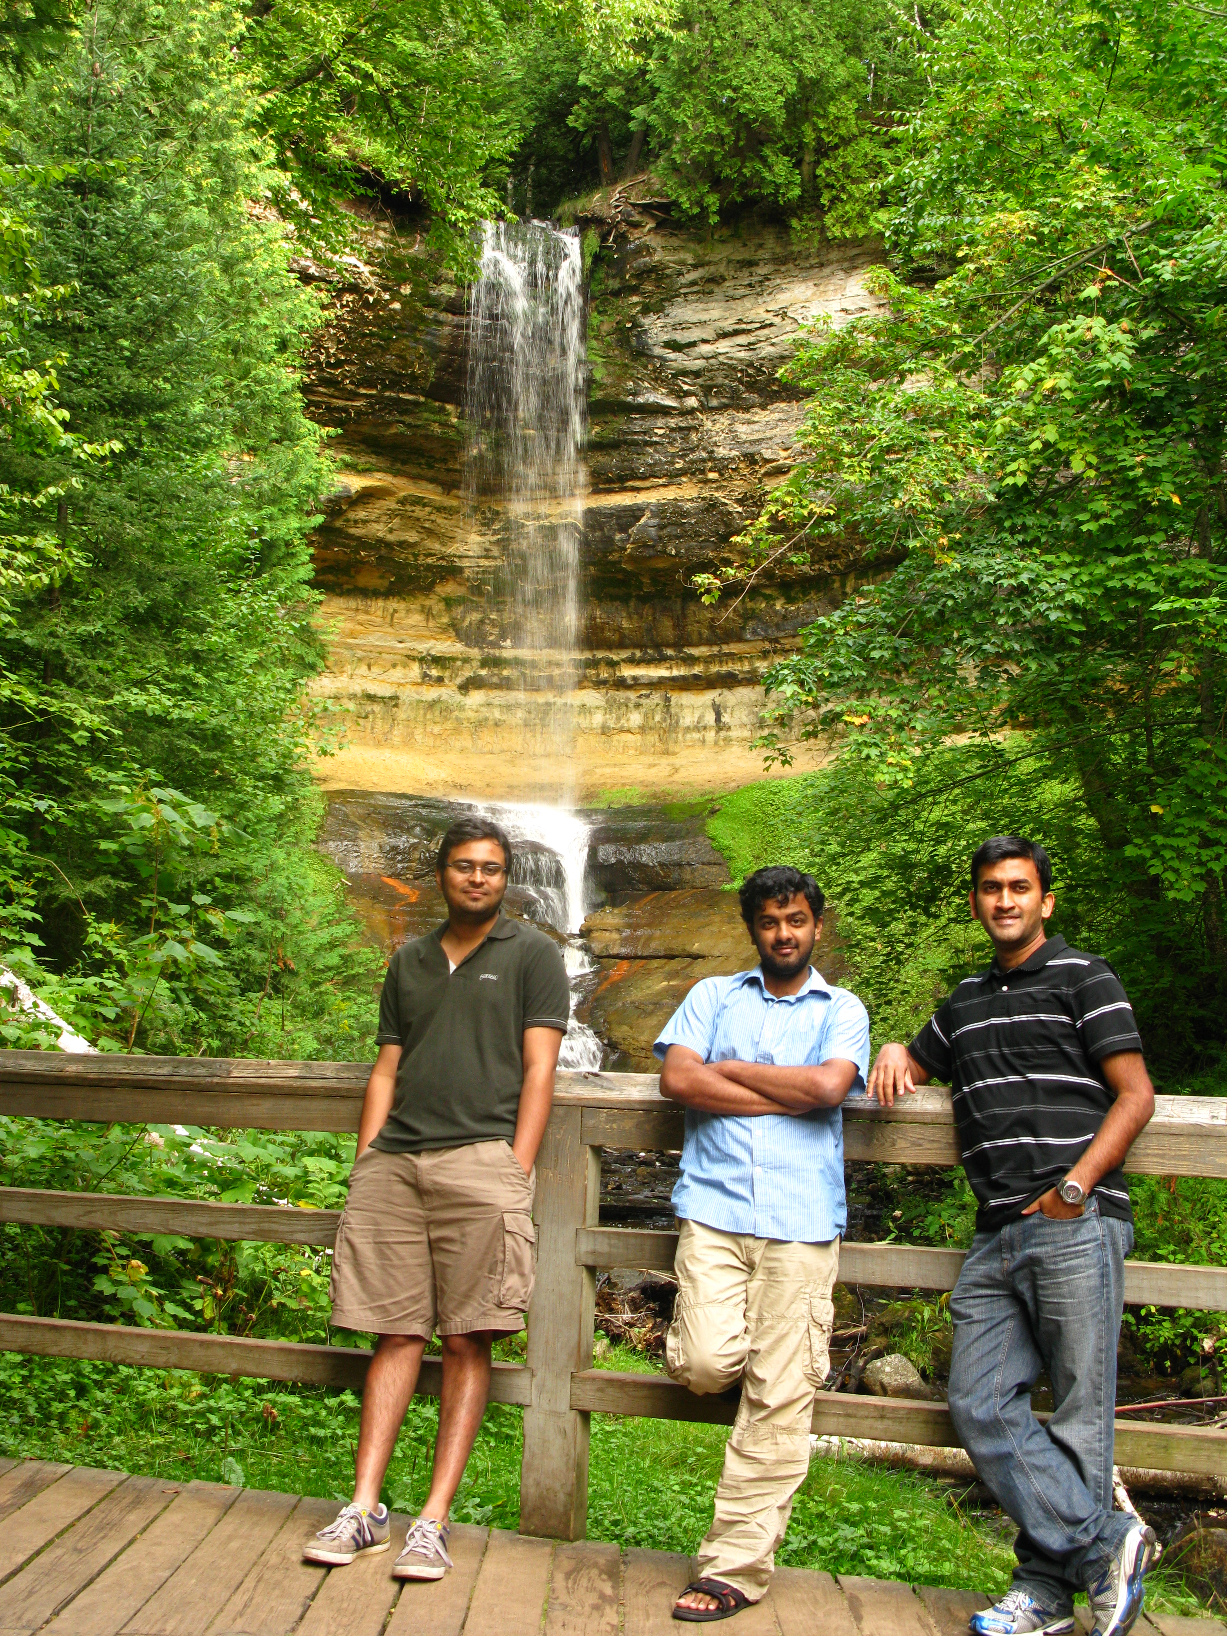

PART IV

In this part values of $γ$ during compression and expansion have been calculated. As logP v/s logV graph is straight line with a gamma slope, a linear fit is obtained for compression and expansion and the value of gamma is determined. The equation used for fit is given by equation 1

|  |  |  |
| --- | --- | --- |
|  | $$logP+γlogV=constant$$ |  |

Table 1 Gamma during compression and expansion for different tests

|  |  |  |  |  |
| --- | --- | --- | --- | --- |
| **Parameter** | **Unit** | **Test 623 6% EGR** | **Test 626**  **18% EGR** | **Test 631**  **28% EGR** |
| **γ**c | (-) | 1.366 | 1.371 | 1.399 |
| **γ**e | (-) | 1.284 | 1.264 | 1.279 |

Following observations can be made from the table

* As EGR increases, $γ_{c}$ increases. As $γ_{r}$ is higher than that of the air-fuel mixture $γ$, higher EGR increases $γ$ of the mixture
* Value of $γ_{e}$ decreases with increase in $γ.$ This is attributed to the fact that BMEP of the engine is kept constant. BMEP is directly related to work done and work done to $γ ,$ which is an aggregate value for compression and expansion strokes. As the value is increasing during expansion stroke, to compensate, its decreasing during compression stroke

**PART V**

Heat release curve is obtained for all the three tests as a function of crank angle (CAD). Equation used to solve for heat release is obtained from equation 2 in the assignment sheet. As values of P, V and CAD are known for the average cycle from the work done in first part of this assignment; this equation can be solved for to obtain the heat release graphs as shown in figure 1.

Following observation can be made from the three curves

* Maximum heat released in case of Test 623 is highest when compared to the other two tests
* Amount of heat released is almost a constant in all the three cases as area under the curves is noticed to be a constant
* In case of test 631, spark advance can be noticed as the peak is closer to TDC. In order to maintain the same BMEP for all the tests, spark is slightly advanced and throttle is opened.

|  |  |  |
| --- | --- | --- |
|  |  |  |

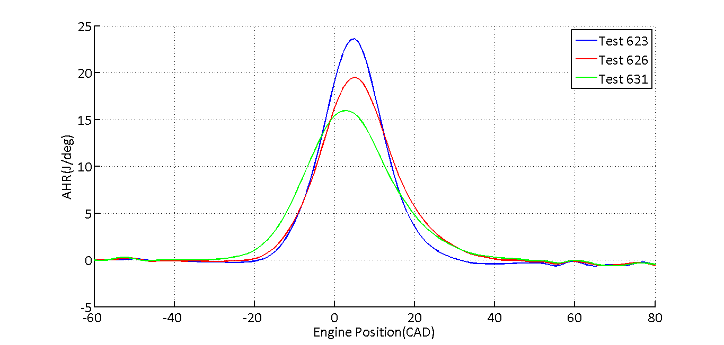

Figure 1 AHR curves for the three tests obtained after filtering using a gamma-factor of 0.94

For the curves obtained in figure 1, integration is performed on each curve and the result is normalized with summation of heat release to scale each graph to a range of 0 to 1. After this process following graphs are obtained as shown in figure 2. Following observations can be made from this graph

* Heat release is start much closer to TDC in case of 623 when compared to the other tests
* Heat release starts early in case of 631 because of spark advance in this test. This is evident from figure 2 where the slope of the curve starts early when compared to other graphs
* This can also be noticed in test 626 but at a smaller scale when compared to that of 631 as this case has an EGR which is an intermediate value between that of 623 and 631

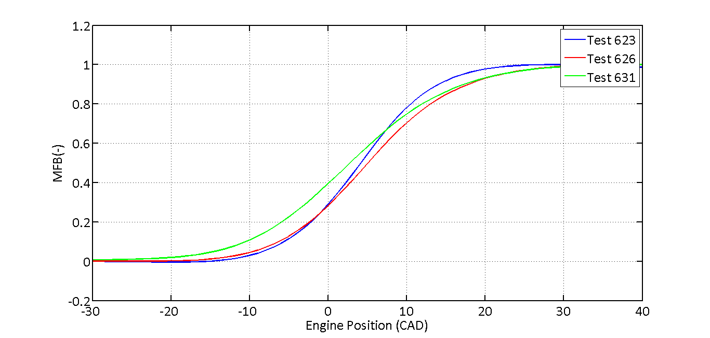

Figure 2 MFB curves for three tests

From the figure, values of CA10, CA50, CA75, CA90 are evaluated for table 2. The values on $γ_{e}$ and $γ_{c}$ are obtained by multiplying theoretical values for corresponding tests determined in table 2 with correlation factor evaluated in matlab code to adjust the curve such that it has a smooth transition from 0.

Table 2 Summary of MFB Results

|  |  |  |  |  |
| --- | --- | --- | --- | --- |
| **Parameter** | **Unit** | **Test 623 6% EGR** | **Test 626**  **18% EGR** | **Test 631**  **28% EGR** |
| **γ**c | (-) | 1.284 | 1.289 | 1.315 |
| **γ**e | (-) | 1.207 | 1.188 | 1.202 |
| CA10 | (CAD) | -5.6 | -6.3 | -10.5 |
| CA50 | (CAD) | 4.2 | 5.0 | 2.9 |
| CA75 | (CAD) | 9.3 | 11.4 | 10.0 |
| CA90 | (CAD) | 14.0 | 17.9 | 17.3 |
| CA10-90 | (CAD) | 19.6 | 24.2 | 27.8 |

PART VI

In this part Wiebe function parameters are fit in order to obtain a mathematical equivalent for the mass fraction burn curves obtained in figure 2. Wiebe function equation used to obtain these graphs is

|  |  |  |
| --- | --- | --- |
|  | $$x_{b}=1-exp⁡[-a{\left(\frac{θ-θ_{0}}{∆θ}\right)}^{m+1}]$$ |  |

In equation 2, $θ_{0}$ is a CA0 value obtained visually from figure 2. $∆θ$ in this case is obtained for a 90% mass fraction burn and this value is evaluated in table 2. $θ$ is CAD value used for calculating averages. Parameters m and a are adjusted in a trial and error fashion to obtain figures 3, 4 and 5. Corresponding values of m and a are entered in table 3. For this work, values of a is a constant of 2.303.

Table 3 Wiebe fit parameters

|  |  |  |  |  |
| --- | --- | --- | --- | --- |
| **Parameter** | **Unit** | **Test 623 6% EGR** | **Test 626**  **18% EGR** | **Test 631**  **28% EGR** |
| **CA00** | (CAD) | -15 | -22 | -30 |
| **CA0090** | (CAD) | 30 | 44 | 60 |
| **m** | (-) | 3.2 | 3.6 | 3.7 |
| **a** | (-) | 2.303 | 2.303 | 2.303 |

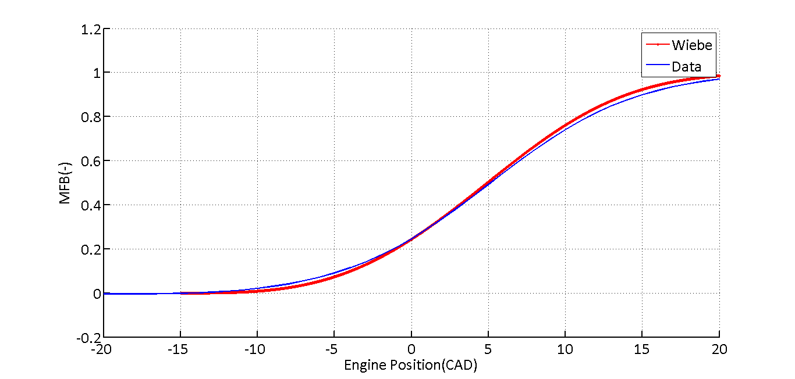

Figure 3 MFB of test 623 overlaid with the adjusted Wiebe function

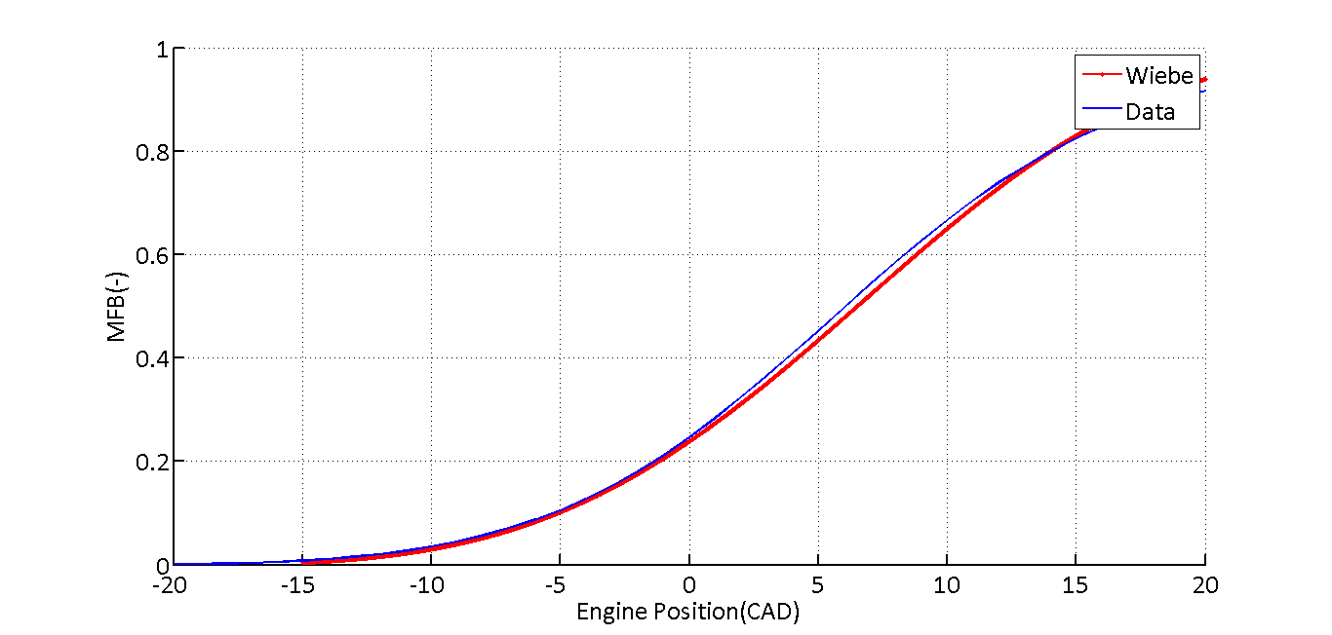

Figure 4 MFB of test 626 overlaid with the adjusted Wiebe function

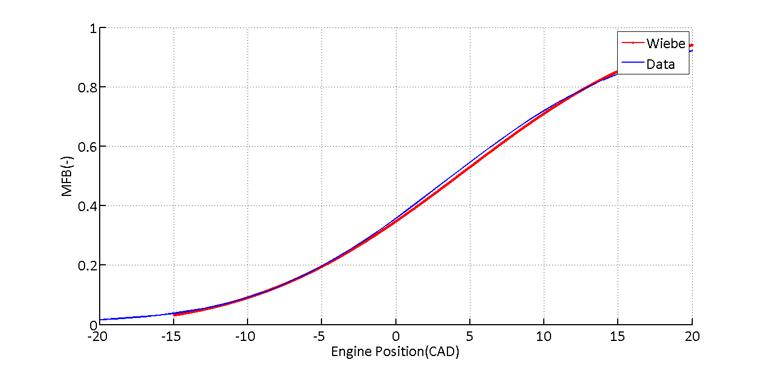 Figure 5 MFB of test 631 overlaid with the adjusted Wiebe function

From graphs, it can be concluded that though, Wiebe function follows MFB very closely, the fit is not accurate. However, this model can be used for the purpose of calculation

**Grade Sheet**

Student Name: *Arjun Darbha .*

|  |  |  |
| --- | --- | --- |
| **Area** | **Points** | **Score** |
| Part IV | 20 |  |
| Part V | 20 |  |
| Part VI | 20 |  |
| Format for Report & Code – following submission  Instructions | 10 |  |
| **Total Parts (IV-VI)** | **70** |  |
| **Total =** | **150** |  |